RAICHU

Remote Access Infrastructure - Controlled Hardware Unit
CmpE195B – Senior Project Report
Ben Tankersley
Thomas Tsang

ABSTRACT

RAICHU - Remote Access Infrastructure - Controlled Hardware Unit
By Ben Tankersley and Thomas Tsang

The goal of technology has always been to enable people, and recent developments in this sector have further enabled people to improve their lives. A driving source of innovation is the demand to improve the quality of life. Cars enabled people to increase their travel distance, telephones enabled people to communicate over longer distances, and the Internet has removed a physical barrier between people. The overall standard of living increases as the innovation and technology continue to grow exponentially.
If the goal of technology is to enable people to do more with less effort, then one of the major proponents driving innovation is to enable technology to be more accessible to everyone. Many personal computers have the ability to be controlled from a remote so people do not have to be physically present at the terminal to be productive; the RAICHU system aims to achieve a similar goal. RAICHU, or Remote Access Infrastructure for Controlled Hardware Units, is designed to enable users to remotely control devices over the World Wide Web. This not only enables people to control devices remotely in real-time, but also allows devices to act on set schedules, or completely autonomous. The RAICHU system is not necessarily about any device or application; RAICHU is about the system. RAICHU enables a multitude of devices to be controlled remotely and simultaneously. By accessing the RAICHU system through a web browser, or a Smartphone, people can control any device on the globe that can access the RAICHU system. RAICHU will allow developers and engineers to integrate remote controlled features into their products with easy.

APPROVED FOR THE COLLEGE OF ENGINEERING
Dr. Frank Lin Project Advisor
Keith Perry, Instructor, CMPE195B/SE195B
Dr. Lee Chang, Interim Chair, Computer Engineering Department

Copyright © 2012
Ben Tankersley Thomas Tsang
ALL RIGHTS RESERVED

Acknowledgments

Thank you to all listed below for your support and guidance
throughout the completion of this project.

Prof. Frank Lin, Ph.D.
Prof. Haluk Ozemek, Ph.D.
Prof. Keith Perry
Preet Kang
Deian Georgiev
Micheal J. Cox

Table of Contents
Chapter 1 Introduction
  - Project goals and objectives
  - Problem and motivation
  - Project application and impact
  - Project results and deliverables
  - Market research

Chapter 2 Background and Related Work
2.1 Background and used technologies
  - State-of-the-art
  - Literature survey

Chapter 3 Project Requirements
3.1 Domain and business requirements
3.2 Functional system requirements
3.3 Non-function system requirements
3.4 Hardware requirements
3.5 Software requirements

Chapter 4 System Design
    - RAICHU Server architecture design
    - RAICHU Server Interface and component design
    - RAICHU Server structure and logic design
    - RAICHU Server Hardware/Software design problems and solutions

    - RC-Car Architecture design
    - RC-Car Interface and component design
    - RC-Car Structure and logic design
    - RC-Car Hardware/Software design problems and solutions

    - Web Application Architecture design
    - Web Application Interface and component design
    - Web Application Structure and logic design
    - Web Application software design problems and solutions

    - Mobile Application Architecture design
    - Mobile Application Interface and component design
    - Mobile Application Structure and logic design
    - Mobile Application Design Problems and Solutions

    - RAICHU API Design
    - Key API Functions
    - RAICHU API Design Problems and solutions

Chapter 5 Project Plan and Schedule
5.1 Project team
  - Project tasks and schedule
  - Project Timeline

Chapter 6 Tools and Standards
6.1. Tools Used

Chapter 7 Testing and Experiment
7.1 Testing and Experiment Scope
7.2 Testing and Experiment Plan

Chapter 8 Project Progress and Status

References

List of Figures
Illustration 1. RAICHU System Design Page No. 18
Illustration 2. RAICHU Controller Flow Chart Page No. 19
Illustration 3. RC – Control Schematic Page No. 21
Illustration 4. Sample RAICHU Web Application Interface Page No. 23
Illustration 5. RAICHU Web Application Functional Flow Chart Page No. 24
Illustration 6. Mobile Application User Interface Page No. 25
Illustration 7. Mobile Application Data Flow Chart Page No. 26
Illustration 8. Testing Progression Page No. 34

Chapter 1: Introduction

  - Project goals and objectives

The goal of this project is create a infrastructure to allow the remote control of devices through the use of the internet. The whole of the infrastructure is made up be several parts all working together to achieve remote capabilities. The server will manage the clients and devices in the system. The devices will utilize the RAICHU API to integrate the remote capabilities into their normal functionalities. Clients will make use of mobile and desktop applications to take control of the remote devices. These three parts of the system will combine to form the entire RAICHU system and each will be discussed in depth throughout this report. The RAICHU system will increase functionality of many devices and also allow for more freedom and peace of mind. Whether it is turning off a light at home that was left on, or monitoring the security cameras at your business while on travel, RAICHU has the potential to make an impact in almost anyone;s life.

  - Problem and motivation

The internet is almost everywhere we go, whether it be via Smartphone, PC or other internet connected devices, we rarely find ourselves more than an arms length away from our next status update, bill payment or shoe purchase. Many companies have realized this change in American culture and have capitalized by allowing internet users to control many things that were traditionally not possible over the web. Major companies such as Safeway, Netflix and Bank of America, are using the internet to allow customers to complete business from the web, without the face-to-face contact that was the norm.
This project seeks to further consumers ability to have an automated and remotely connected life. Similar to Bank of American features, where a customer can transfer money, automatic pay bills each week, and check on balances from anywhere the world, RIACHU seeks to enable users this type of remote power in other aspects of life. Whether it is turning a light off from across the United States, or ensuring you locked the door when you were the last to leave the office, RAICHU's goal is to empower its users to do more with speed and ease. With everything taking to the cloud, RAICHU will help bring devices to that cloud and help developers get web enabled products to market.

  - Project application and impact

The RAICHU system has the potential to impact many aspects of academia, the industry, and society. RAICHU utilizes many components to formulate its' core functionality. The project is developed on several open source technologies, and the code will also be open sourced for community development and improvement.
Academia has the ability to benefit from studying and implementing the RAICHU system by the interfacing with devices and taking a deeper look into the semantics of the server architecture. The RAICHU system covers many topics that are addressed in academia focusing on modern computer and cloud systems . Utilizing key concepts of networking, database technologies, embedded systems, real-time operating systems, mobile and web applications and many other technologies that converge into one system students can benefit from the RAICHU system.
Industry impact will be determined by the open source community, where developers are free to enhance and maintain the project and improve/increase functionality of the system. The hopes of the creators of RAICHU are such that RAICHU will continue to grow after the scope of this project to become a very well know system for getting devices connected to the could. This is only possible with vast community support and adoption of RAICHU. It is not easy to penetrate into an industry that is dominated by well know players such as Google and NetApp, but with a strong foundation and highly usable code base, it is possible to form new standards and affect the market on a much high level than just selling one product. RAICHU will be an every growing and evolving system and, in time, has the potential to make a very large impact on the industry.
The greatest impact of RAICHU would be on society and people's everyday way of life. Since users will be able to take remote control of devices and automate their devices' functionality, many everyday activities will become trivial tasks that can be done from the comfort of their couch or 35,000 feet in the air. RAICHU has the ability to alter day-to-day life for many people and allow developers to get cloud technologies into the hands of consumers faster and easier. Within a small amount of time, RAICHU can change lives forever.

  - Project results and deliverables

There are three main deliverables for this project that make up the core of RAICHU: the server, the web applications and the API. For the purpose of demonstration, devices such as a small RC car, a media player, and power bank of wall outlets will be designed with the RAICHU API to utilize the capabilities of the RAICHU system. The final results of this project will be a working prototype of the first RAICHU system. This prototype will then become the base system that the open source community can use, contribute too and evolve into a much larger entity. The system that is designed is a proof of concept in sorts and will not necessarily address every known issue with creating such a large scale system. Yet, these short comings will be identified, and if possible, long term solutions may be laid out to solve these problems. It is also a hope that this project will spark the imagination of developers and consumers alike, and spark a movement to use RAICHU and formulate a standard in creating an “Internet of Things.”

1.5 Market research

There are several companies on the market that offer similar products to that of RAICHU; namely Smart home, ioBridge and more recently Comcast. The first two companies mentioned specialize in creating products to help automate features in your home such as power outlets and smart light switches. However, what these two companies lack is an all encompassing system for controlling and maintaining these devices. The products they offer are very neat, but do not effectively solve the problem of creating an internet of things.
The products that Comcast has to offer are the closest thing to the RAICHU system. For monthly fees, Comcast offers a service dubbed Xfinity Home. This is a home security system that also allows the user to integrate devices into their security system such as light switches, thermostats and security cameras. The Xfinity Home system is very robust, However, we believe it to have a very large shortcoming. The system only allows users to add on devices that are sold by Comcast and only covers the realm of home security. RAICHU seeks to mimic Comcast in many aspects but also improve in area's where they fall short by allowing developers to integrate any device into the system and users to access a much larger array of devices.
Companies that specialize in this field generally do not have the sales and revenue of other tech companies. It is our goal to help this market emerge as a viable leader in the consumer electronics industry and open the door for similar companies to help extend the reach of web-enabled devices to all knew heights.

Chapter 2: Background and Related Work

2.1 Background and used technologies

The RAICHU server architecture utilizes three main components: a
HTTP server, database server, and device control server. The HTTP server is an Apache based web server that is developed with open source software from the Apache Software Foundation. Initially released in 1995, Apache has been developed and maintained by an open source community and is available under a plethora of operating systems. Since April 1996, Apache has been most popular HTTP server in use; Apache is estimated to server 57.46% of all active websites and 65.24% of the top servers across all domains. By utilizing a well known system for the HTTP server, we are not only reducing the amount of background leg work in producing a new server, but also sticking to norms of the industry. This will allow for future upgrades to the system with more ease than if we went with our own server or a not as well known and maintained system.
For our database server, we chose to use MySQL, currently the world’s most used relational database management system. We chose MySQL due to its abundance of features (such as multiple database storage engines) and for its broad community support. Many high profile web applications use MySQL as their database backend, such as Wikipedia, Facebook, and Twitter. The widespread use made MySQL and easy choice for the database portion of RAICHU.
The last of the components is a custom device control server written in Python. The device controller bridges the gap between RAICHU devices and the server components, as the device controller server interacts with the database and the web server to control devices. This is the portion of the RAICHU server architecture that will contain the most intellectual design and will absorb a large majority of development time.

2.2 State-of-the-art

Most of the devices that are currently on the market are controlled by infra-red and radio frequency telemetry systems. However, there is one company that has made large strides in the area of connecting devices using the internet: ioBridge. ioBridge manufacturers Internet-enabled devices and products for vendors to avoid the complexity of piecing components together from multiple sources. IoBridge is doing a lot of ground work in producing web-enabled devices and building a consumer market in that are. However, RAICHU seeks to be a part of the state-of-the-art and contribute to this newly booming market sphere.

2.3 Literature survey

Aside from ioBridge's documentation and products, we came across a protocol written by Chris Armbruster to standardize the communication format sent over the web from embedded devices. Armbruster’s protocol focuses on “controlling and monitoring devices connected to the Internet”. This protocol is similar to the framework we are looking to create as it is pushing for a standard that can be used when control devices that reside in a remote location. There is much room in this field for an official standard to be created and implemented by IEEE as many more companies and consumers are looking for a standardized method of controlling remote devices over the web.

Chapter 3 Project Requirements

3.1 Domain and Business requirements

Name | DBR-01: Control in Real Time
Summary | The RAICHU system should allow for remote access in real time from any location in the world that has access to an Internet signal.
Rationale | After a user selects a device and a relay is created by the server between the device and the client, control and feedback from the device should occur in real time. This will allow users to interact with time crucial devices and know their commands will execute within an acceptable time frame.
Requirements | > The client should have a active connection to the server and active relay should be maintained to the device for the duration of use.  > Client commands are valid and the connection is dropped during relay.  > Device is in a state than can accept and react to user/RAICHU commands.  > Device reacts in real time to user commands.

Name | DBR-02: Simultaneous Control of Multiple Devices
Summary | The RAICHU system should allow users to interact with multiple RAICHU enable devices simultaneously.
Rationale | Users of the RAICHU system should have control of all of their devices extended to them at the same time. For instance, a user that has three light switches and a door lock for one location, should be be able to control all devices at the same time.
Requirements | > Robust sever that allows client to access multiple devices and control them at the same time.  > Device is in a state than can accept and react to user/RAICHU commands.

Name | DBR-03: Functional for Commercial and Consumer Use
Summary | The RAICHU system should allow be functional and usable for commercial and consumer use.
Rationale | The RAICHU system should present value to both commercial and consumer users. A company should be able to use the system for managing lighting, locking the doors and surveillance, while consumer users should be able to schedule their heater, and close their garage door. The RAICHU system should have the capacity to benefit everyone and make on impact to everyones lives.
Requirements | >Web and mobile applications should allow for in depth customization to fit individual use cases.

3.2 Functional System Requirements

Name | FR-01: Remote Connection from Anywhere
Summary | The RAICHU system should allow users to connect to their devices from anywhere in the world.
Rationale | Whether a user is in their living room or in another country, if they have internet access, they should be able to access and control their devices from either a mobile application on their smartphone or a web application on their personal computer.
Requirements | >Web and mobile applications that are user friendly and easily accessible from anywhere.

Name | FR-02: Plug-N-Play Functionality
Summary | The RAICHU system should allow for users to add devices to system semi-autonomously.
Rationale | The setup and connection to a remote RAICHU device should be nearly as simple as plugging it in. This will allow users of the system to spend less time configuring and more time using.
Requirements | >Advanced server and device API that allow for quick connection capabilities and little user interaction.

Name | FR-03: Mobile and Web Applications
Summary | The RAICHU system should allow for devices to be accessed through both mobile and web applications.
Rationale | Users should never have to be more than an arms length away from monitoring and controlling their devices. This could mean sitting at their computer at work or on the bus with their smartphone. RAICHU keeps users connected.
Requirements | >Design of both web and mobile applications to support RAICHU client connections to devices.

Name | FR-04: Device Ownership
Summary | The RAICHU system should allow for multiple users to have “ownership” of same device and conversely allow multiple devices to be controlled by the same user.
Rationale | There are many instances where a device should be able to receive commands from multiple users, such as a husband and wife controlling their garage door. This option should be settable via the mobile and web applications and kept persistent in the data base. Devices should also be able to be marked as a “lockable” device. Meaning that when one users has the device, no other authorized users can interact with the device until the lock is released.
Requirements | >Ability to save device settings and retrieve those settings to correctly provision ownership.  >Continuously updated knowledge of device status.

Name | FR-05: Device Feedback
Summary | The RAICHU system should allow for devices that are feedback enabled to deliver important information to users through email and push notifications, even if the device is not currently being used at that time.
Rationale | There are many instances where a device should be able to receive commands from multiple users, such as a husband and wife controlling their garage door. This option should be settable via the mobile and web applications and kept persistent in the data base. Devices should also be able to be marked as a “lockable” device. Meaning that when one users has the device, no other authorized users can interact with the device until the lock is released.
Requirements | >Server to allow for email and push notifications if device requires it.  >Continuously updated knowledge of device status.

Name | FR-06: Wireless Connectivity
Summary | The RAICHU system should allow for devices that are Wi-Fi enabled.
Rationale | The initial prototypes for the RAICHU system all run on Wi-Fi. Although a wired system would still work. It is outside of the scope of this project. With a Wi-Fi enable device, converting it into a wired device should prove to be trivial with the correct hardware.
Requirements | >Wi-Fi connectivity of RAICHU enable devices.

3.3 Non-Function System Requirements

Name | NFR-01: User Friendly Applications
Summary | The RAICHU system should have web and mobile apps that are fast, powerful and user friendly.
Rationale | It is far to common for a person to get new device and only use it the first time they open and then place it on a shelf to gather dust. Also, over 95% of mobile applications are only opened one time after being installed on a device. RAICHU needs to present users with and easy to use interface that is fast and fun to keep users coming back, and utilizing their RAICHU devices to the full os their potential.
Requirements | >Web and mobile apps that are fast, powerful and user friendly.

Name | NFR-02: Safe and Secure Control
Summary | The RAICHU system must be secure to keep unwanted users and threats from attacking the system.
Rationale | When a powerful system such as RAICHU can be controlling things such as security cameras, locks and even safes, it is all too important to have a strong security system that can prevent unwanted users from gaining control of devices.
Requirements | >Strong security interface

  - Hardware Requirements

- RAICHU Server
  - Core i7 Desktop computer to host servers
- Remote Controlled Car
  - 1 - Lpc2148 Arm micro controller and breakout board.
  - 2 - dc motors
  - 2 - electronic speed control circuits
  - 3 - axis gyro
  - 3 - super sonic distance sensors
  - 1 - WiFly Wi-Fi module
- Power Bank
  - 2 - 240 VAC relays
  - 2 - commercial power outlets
  - 1 - WiFly Wi-Fi module
  - 1 – mBed micro controller

Note: The hardware requirements mentioned are based on devices that can utilize the RAICHU system. They are being created to demonstrate the systems ability to control devices that are based on different platforms and different end use cases.

  - Software requirements

- Server Development Tools
  - Python
  - Apache
  - MSSQL/MySWL database software
  - Sublime Text 2
- Device / API Development Tools
  - Eclipse
  - Visual Studio 2010
  - Hercules Terminal
  - HyperLoad boot loader
  - mBed tools
  - FreeRTOS
- Mobile and Web Applications
  - Eclipse
  - Clang
  - Sublime Text 2
  - Adobe FlashBuilder
  - Adobe ColdFusion

Chapter 4 System Design

4.1.1 RAICHU Server Architecture Design

The overall encompassing design of the system includes hardware devices, web/mobile clients, and the server. Example devices are covered in below sections. This section will detail the server application of the system. The server is broken down into three components: the web server, the database server, and the RAICHU controller application. The components will be explained in order of execution.
Upon boot up, the RAICHU controller will listen for incoming connections from devices or clients. Upon accepting a connection, the controller will then cache the device info and also log it into the database. Any sort of information related to the device is logged, such as the name of the device, IP address, port number, connection and boot up time, and device type. The controller needs to log the device type to understand how to support the device. For example, the controller supports MP3 functionality, thus the controller needs to know how to play songs and be able to generate an interface for connecting clients. Once clients connect, the client receives a list of available devices to connect to. When the client selects which device to connect to, the controller locks down the device so that no other client can take control of it. In the background, the controller batches SQL queries to send to the database server. There is a common queue used by all threads to push in queries to be executed periodically. After establishing a connection, the server then proceeds to relay data between the client and the connected device. If a client or device disconnects for any reason, the controller removes the entry from its own cache and marks it offline in the database.
For the database server, we use MySQL 5.5. We chose to use InnoDB as our database engine for it’s support of foreign keys and transactions. Although MyISAM’s feature for full-text search index is useful, the scope of our project does not require it.
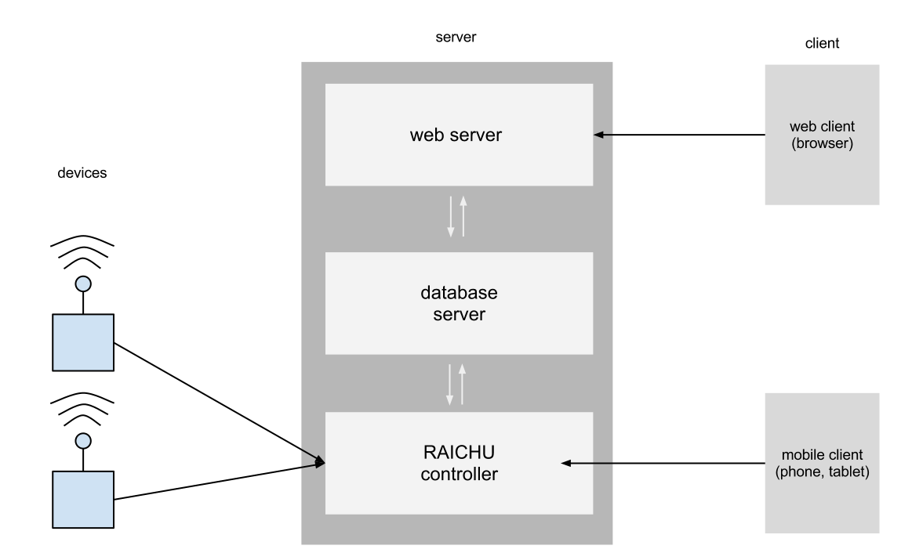Illustration 1: RAICHU System Design

4.1.2 Interface and component design

When clients and devices boot up, they connect to a designated server over TCP/IP. Once the connection is established, the clients or devices exchange information with the server. Although TCP/IP has more overhead than UDP, we required the reliability asset of the protocol more than the lightweight and speed of UDP. Even though we utilize real time data transfer, a packet’s integrity is especially important since all the data is sent as strings, thus we can’t afford to drop any packet as applications utilizing UDP can.

4.1.3 Structure and logic design

The structure of RAICHU relies on its core components, which are the web server, database, and the RAICHU controller. This current iteration has a simplified architecture to ease up on design and implementation.
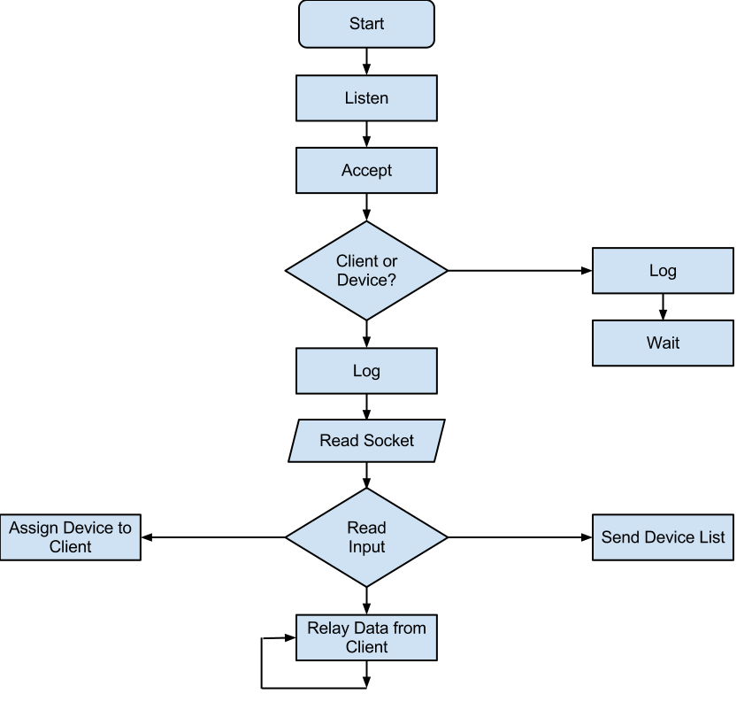Illustration 2: RAICHU Controller Flow Chart

4.1.4 Hardware/software design problems and solutions

We considered two models to introduce concurrency into the system. The other model is the event driven model. Although the event model scales much better as it reacts based on incoming events, it is much more difficult to design and test. Instead, we went with the classical thread model, where each connection is handled by a separate thread. Although this model does not scale as well, we were compelled to demonstrate a proof of concept so we chose this model.
Although multithreading is an asset to the server, it also introduces many issues. Multithreading in this system introduces issues concurrency issues on reading and writing data, therefore data has to be isolated properly or implemented with locks.
One issue we encountered was that the MySQL db module that was imported was crashing during high traffic calls. A solution we implemented was to push all the queries into a common queue, where we then executed the SQL queries in batches to reduce stress on the RAICHU controller and on the database server. However, this creates a consistency issue between the RAICHU controller and the database server since the database server will always be a few seconds behind the controller.

4.2.1 RC Car Architecture design

The RC component is designed to show RAICHU users the real time capabilities this system has to offer by allowing control of the device from a remote location in real time. The architecture of the system is rather straight forward for a RC car system. The RC car incorporates a hardware system that consists of two DC motors that use PWM circuits for speed control along with a main micro controller that operates the car and its multiple functions. The car communicates to the RAICHU system through the use of a Wi-Fi module that allows it to connect to a wireless internet signal. The software that is utilized in the car is a real time operating system that allows for effective resource management of the car and allows for the car to have multiple states of operation consisting of: On/Off, Park, Drive and Roam. The RTOS also allows for an effective mesh of the hardware devices with a software interface to allow for simple control over the RAICHU system. The Wi-Fi module that will be used in all devices through this project is the Roving Networks Wi-Fly. This is a feature packed device that is capable of connecting to a wireless network and establishing a connection to a host. The RAICHU API allows for easy configuration of the Wi-Fly device.

4.2.2 Interface and Component Design

The car will consist of an NXP LPC2148 micro controller as its core that will control two motors via PWM motor controllers. One motor will be for forward/reverse and the other will be for steering. Distance sensors are incorporated to keep the car from running into obstacles. The car will get its commands on which directions to go via an integrated Wi-Fi module that will connect the car to the rest of the RAICHU system. A detailed schematic can be found in the appendix.

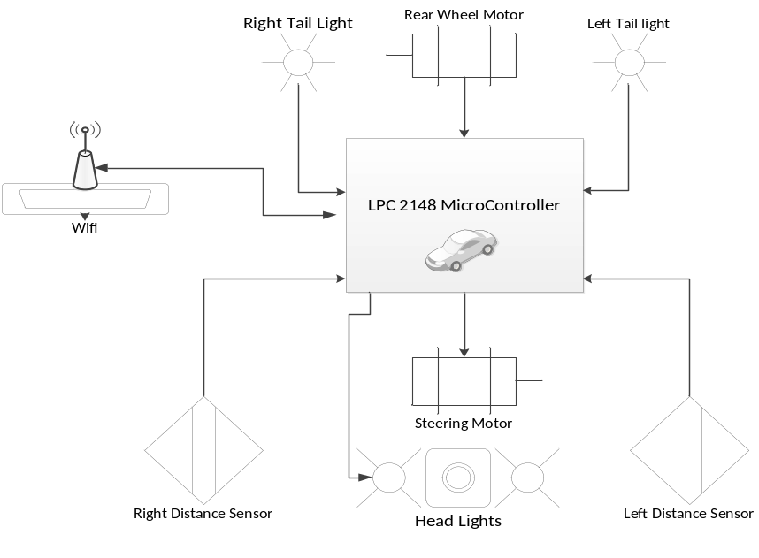Illustration 3: RC Car Control Schematic

4.2.3 Structure and logic design

The logic that powers the cars micro controller is a C language based real time operating system name FreeRTOS. This is an open source OS for embedded devices that allows for process scheduling and interprocess communication that will allow the RC car to be easily integrated into the RAICHU system. The OS will run two main processes: one that is controlling the forward/reverse and left/right speeds and another that is constantly updating the motor values by receiving commands from the RAICHU server via a client. OS handles will be used for inter process communication. To implement the functionality needed by the Wi-Fi board the RAICHU API will used.

4.2.4 Hardware/software design problems and solutions

The main hardware and software problem that is found in the RC car portion of the RAICHU system is the fact the car is going to have to be controlled in real time from a remote location. With any internet application there is always the possibility of lag and loss of transmission packets due to a slow or weak connection. There is no full proof way to ensure that the system will never run into a conflict like this but there are multiple things that can be done in both hardware and software that can help prevent a collision in the event of slow or lost transmission.
The first thing is selecting hardware that will allow for fast transmission of the commands to the car and also hardware the boasts strong signal characteristics so the chances of losing a signal due to interference or range are reduced.
The other ways to prevent collisions and data loss are adding software checks and feedback loops. One check will be on the embedded device side to ensure that the Wi-Fi module and micro controller are receiving commands from the server.. If it detects a loss in commands, it will assume there has been a loss in connectivity and the device will put itself in park, preventing it from becoming a ghost car. Another check will be implemented on the RAICHU Server side to make sure it is constantly in communication with the device and that the device is powered and ready to run. Software checks can put the car in park when it senses a loss in signal strength/ throughput which will overall prevent the car from incurring unwanted collisions.

4.3.1 Web Application Architecture Design

RAICHU relies on both the web application and mobile application to provide users with a easy and reliable platform for controlling their devices. The web application will cater to users that are seeking to control their devices via a personal computer. This may prove useful for companies and business looking for a total security system that allows them control not only surveillance but also locks, lights and thermostats. With highly interactive and intuitive design, users will have the ability to customize their experience with each device. The web application will also server as the first configuration platform for new RAICHU devices. A user will have to first to connect to their RAICHU device through the web application to run initial setup on their device and calibrate control data. The web application will also allow users to customize the interact they will have with their device that they plan to use predominantly with the smartphone application.
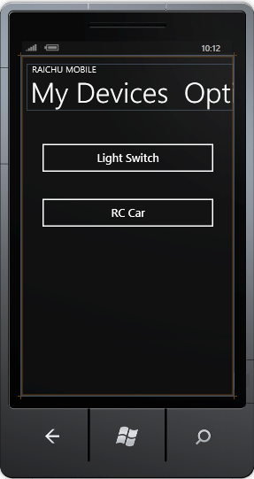Illustration 4: Windows phone applcation interface

4.3.2 Web Application Interface and Component Design

Illustration 5: Sample RAICHU Web Application Interface
The web application will be created using Adobe FlashBuilder and take advantage of the Flex framework. Flex utilizes Actionscript and Java to create rich web applications. The user interface and control functionalities of the web application are an important component to the success of this project and when looking for a strong environment to create this platform, Flex seemed to fit the bill for what was needed. Many industry leaders such as Mini Cooper, Adobe, and Lytro use Flex to create their online user experiences. Flex not only allows for fast , streamlined creation of rich web applications but also allows developers to sync their front-end with a database backend with ease. A middle-tier software framework is needed to pull information from the database and present it to the Flex interface and to fulfill this requirement we decided to use ColdFusion. ColdFusion is a proprietary middle-tier framework developed by Adobe to coincide with a Flex front end. By using frameworks created by the same design house, we are ensuring that they will work well together and introduce little friction in the design process. The web application is an important piece of the RAICHU system but it is only a small piece that makes up the whole and it is very easy to get lost in creating a rich, interactive web application. The Adobe products will simplify this flow and allow for a working prototype, that is also visually pleasing, to be created and used in testing of the prototype RAICHU system.

4.3.3 Web Application Structure and Logic Design

The flow of information in the web application is very simple. There are event listeners linked to the database server and python server that can update the UI whenever data changes by utilizing the properties of the ColdFusion middle-tier. The diagram below briefly shows the flow of information through the web application.
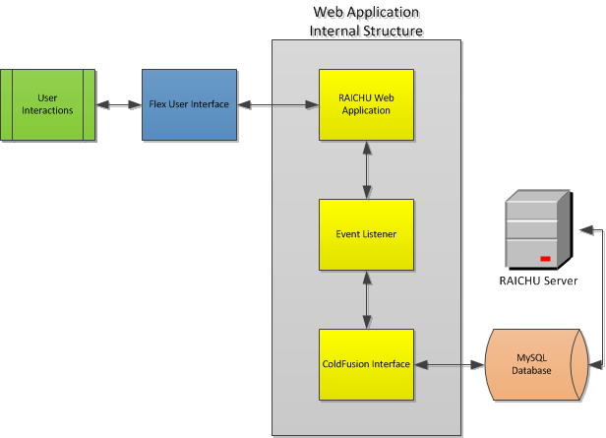Illustration 6: RAICHU Web Application Functional Flow Chart

4.3.4 Web Application Software design problems and solutions

The only major issue that presents its self in creating a rich web interface for the RAICHU system. The design is rather straight forward, however it is always hard to create a user interface that is both engaging, visually pleasing, and user friendly. Many companies spend a large part of their yearly budget on their web site and we will be creating this site in a little under a month. It is hoped that this will turn out to be a very awesome product, but there is a large amount of trial and error that will take place in getting this web interface to a fully functional state.

4.4.1 Mobile Application Architecture Design

RAICHU seeks to find a home on every major platform that is currently on the market in smartphone territory. The three major platforms, Apple's iPhone, Android powered phones and Windows Phones, leave plenty of room for app development and widespread product availability. Unfortunately due to the time constraints placed on this project and limited resources, we decided to develop a mobile application solely on the Windows Phone platform utilizing the WP7 SDK. The Windows Phone SDK is a C# based code source that allows for simple UI creation and database connectivity. Our team has had experience with the WP7 SDK and is comfortable in creating a mobile application that will showcase the abilities of the RAICHU system in a timely fashion. The phone will mimic the web application in many of its abilities but RAICHU devices will still have to be pre-configured using the web application to be used by the mobile application. If development time allows for Android and iPhone ports of the Windows app a broader range of devices may become usable on the initial RAICHU prototype.

4.4.2 Mobile Interface and Component Design

The mobile application will be designed inside Microsoft Visual Studio 2010 which has a very interactive and intuitive UI creator that will allow for the device to run smoothly as a native application and blend seamlessly with the look and feel of the Windows Phone 7 OS. With a powerful API for connecting to a database, the application will not have to make use of a third party middle-tier as did the web application.

4.4.3 Mobile Structure and Logic Design

The Windows phone implement a similar data flow to that of the web application. This can be seen below in figure NEED TO ADD FIGURE NANME.
The device will connect to the server and allow the user to select a device. Once the server is able to establish a relay connection between the device and the client, the user will be able to view a list of valid commands for that device. For example, when a user selects a light in their home, they will be presented with the current state of the light (on/off) and also the controls to alter the current state. All database connections, UI interactions and wireless communications will be handled using the WP7 SDK.

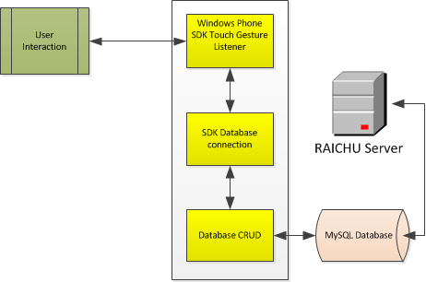Illustration 7: Mobile Application Data Flow Chart

4.4.4 Mobile Software design problems and solutions

The main issue in creating a mobile application for this project, or any project for that matter, is having creating widespread availability for users of different mobile platforms. In an ideal world, our project team would consist of five mobile designers each specializing in a different platform. However, our group is limited to skills that pertain to Windows Phone devices and so for the time being, only a WP application will be created. It will still server well as a mobile client and showcase the abilities of the RAICHU system over a mobile interface.

4.5.1 RAICHU API Design

In order to get developers using the RAICHU system, and using it with ease, we decided to create an API that will allow developers to include RAICHU functionality into their Wi-Fi enabled devices. The RAICHU API currently has support for the Roving Networks Wi-Fly module and will continue to grow with open source community support and desire for a wider range of Wi-Fi module support. The API was developed in C code for use in embedded devices. However, this too will grow over time and evolve to support many other programming languages.

4.5.2 Key API Functions

There are several key functions in the API that most developers will require to implement RAICHU functionality into their devices. These functions, their purpose and application notes are as follows:

Name | API-01:int RAICHU_init(RAICHU_instance)
Summary | This function will construct a new RAICHU instance within the code base and allow the user to take advantage of the APIs data structures that will be needed to use many of the other API functions.
Sample Implementation | #include <stdio.h>  #include "raichu.h"  RAICHU_Instance test_device;  int main ()  {  int success;  success = RAICHU_init(test_device);  success = success || setDeviceName(test_device, "4 outlet power bank");  if(success)  {  printf("New RAICHU Device instance created with name: %s\n",getDeviceName(test_device));  }  else  printf("Error creating device \n");  return 0;  }
Return Value | Function will return 0 if the RAICHU device is created successfully, else it will return a positive number based on where the initialization failed.

Name | API-02:int RAICHU_setDeviceCommands(RAICHU_Instance, char * commands[])
Summary | This function will let the server know what commands the RAICHU device has for remote availability. This function must be called before the RAICHU device is connected to the server. Commands can be changed during operation, however, the device must disconnect from the server, call this function again, then re-instantiate server connection.
Sample Implementation | #include <stdio.h>  #include "raichu.h"  RAICHU_Instance test_device;  int main ()  {  int success;  char * commands[] = {“on”,”off”};  RAICHU_init(test_device);  success = RAICHU_setDeviceCommands(test_device, commands);  if(!success)  {  printf("RAICHU Device has %i commands named: %s\n",RAICHU_getNCommands(test_device),RAICHU_GetCommands(test_device);  }  else  printf("Error setting device commands \n");  return 0;  }
Return Value | Function will return 0 if the RAICHU device commands are not set successfully, else it will return a positive number that corresponds to the number of commands set.

Name | API-03:int RAICHU_serverConnect()
Summary | This function will attempt to connect the device to the RAICHU server and allow the server to add it to the device database. This function is necessary for any device that wants to connect to the remote server.
Sample Implementation | #include <stdio.h>  #include "raichu.h"  RAICHU_Instance test_device;  int main ()  {  int success;  char * commands[] = {“on”,”off”};  RAICHU_init(test_device);  RAICHU_setDeviceCommands(test_device,commands);  success = RAICHU_serverConnect(test_device);  if(!success)  {  printf(“RAICHU device connected to server, info: %s” , RAICHU_getConnectionStatus(test_device);  }  else  printf("Error connecting device to server \n");  return 0;  }
Return Value | Function will return 0 if the RAICHU device does not connect to the server successfully, else it will return a positive number that corresponds to server issued connection id number.

The functions mentioned above to complete the API rather they constitute a small subset of the API and demonstrate its architecture and naming convention. For a full reference document to the API, see the appendix for a link to the information.

4.5.3 RAICHU API Design Problems and Solutions

The RAICHU API represents a living code base that will continually undergo changes to keep up with modern standards and new feature support. At its current state. The API supports only a small subset of the intended use cases, but with open source community support and constant pushing for more and more devices to become web enabled, RAICHU can continue to grow and become a standard for remote access of cloud devices.

Chapter 5 Project Plan and Schedule

5.1 Project Team

The RAICHU team consists of Thomas Tsang and Ben Tankersley. As computer engineering students both team members are assuming multiple roles in both the hardware and software development of the RAICHU system.
Thomas is mainly focusing on the framework that will be the backbone of the RAICHU Server system. The software and networking aspects of managing multiple devices over the internet is being handled by Thomas as well. This allows Ben the ability to focus on other aspects of the RAICHU system such as device integration, mobile and web applications and more of the front in aspects that RAICHU users will encounter. Although each team member has clear roles, as a part of the RAICHU team each member contributes to the others work when needed. This not only allows for more complete and concise team understanding of the system but also adds an added level of functionality to the system as each team member has valuable ideas, methods and skill sets that will make the RAICHU system come to life.

5.2 Project Tasks and Schedule

The project task and schedule are based on a two semester timeline. These two periods can be broken down into two basic project periods: Research and Design, and Implementation and Testing. The Research and design phase will span from January 2012- roughly mid-July 2012. The Implementation phase will pick up where the Research phases ends in mid-July and span to the end of the fall semester in December 2012.
- Research and Design
  - Initial Project research
  - Prototyping Project Components
    - RC Car
    - Home/Business devices
    - RAICHU Server framework
    - Web and Mobile Apps
    - RAICHU API
  - Initial prototype Testing
- Testing and Implementation
  - Test Prototypes
  - Document initial design flaws
  - Rework prototypes
  - Begin Implementation of reworked designs
  - Launch for initial testing
  - Final testing
  - Launch Completed RAICHU System

Chapter 6 Tools and Standards

  - Tools Used

There are numerous different tools used in the creation of both the hardware devices that will be interfaced into the RAICHU system and also the software aspects.
- Hardware:
  - Various micro controllers and supporting peripheral hardware devices: These micro controllers will be the basis for each hardware device that is incorporated into the RAICHU system. The micro controllers will act as the “brain” in each device. For prototyping RAICHU devices this project will utilize two different micro controllers: NXPLPC2148 and NXP mBed.
  - Roving Networks WiFly Wi-Fi module: This module will be incorporated into each device as it is going to serve as the medium between the RAICHU server and the devices themselves. The current RAICHU API only supports this Wi-Fi module.
  - Mobile Devices: Various mobile devices and platforms will be used to host the applications that can connect to the RAICHU servers and allow for mobile control of devices.
  - Server: A server will be needed to host the RAICHU web application, RAICHU database and Client Server.

- Software:
    - Apache HTTP server
    - MySQL
    - Python
    - Clang
    - Eclipse
    - Visual Studio 2010
    - Adobe FlashBuilder
    - Adobe ColdFusion
    - mBed Compiler

Chapter 7 Testing and Experiment

7.1 Testing and Experiment Scope

There are separate testing procedures for each aspect of the RAICHU system. The RAICHU framework: which consists of the server, middle-tier and front end are all software, while the RC car, Quad-copter and home/business devices are hardware components that not only have to work individually but also have the ability to be integrated into the RAICHU system. Each device must be tested separately for functionality before the system is combined as a whole and tested as large unit.

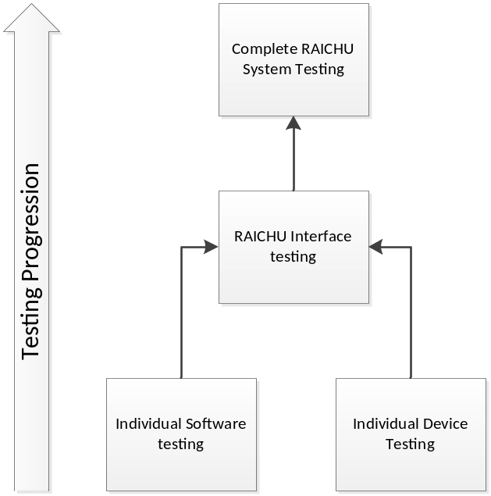Illustration 8: Testing Progression

7.2 Testing and Experiment Plan

Each device will be individually tested for functionality outside the realm of RAICHU. For instance, the RC car will be tested for the abilities to drive, turn etc. These capabilities will all be tested over Wi-Fi as that is the way the devices will be controlled from the RAICHU server.
Before testing devices, we first had to test connectivity with the Wi-Fi modules. To test, we would connect the Wi-Fi modules to a USB dongle to talk to it over UART. Once we can establish consistent connections, we can safely assume the code to transmit and receive data over UART is working.
Each device will be individually tested for functionality outside the realm of RAICHU. For example, the RC car will be fully tested for ability to drive prior to integrating with RAICHU. The RC car will also be tested for driving under poor Wi-Fi signal. One issue with the car was steering straight, until we realized no voltage is required to steer for the spring to set it straight.
Prior to integrating with the server, the server itself is tested with simulated clients and devices. To do that, Python scripts were set up to simulate what connecting clients and devices would do. Additionally, there is a controller script that can create multiple devices to connect to the server. This script is utilized to stress the server so simulated clients can have a multitude devices to select from and send data to. Internally on the server, there are CLI commands that can be called to check on cache data such as devices and clients.
The RAICHU software will all be tested independently of the devices up until the point of integration. The software modules will all be instantiated to perform their basic functions. After the testing of basic functionality is completed a more complex user interface will be added to enhance the visual appeal of the software.

Chapter 8 Project Progress and Status

As of December 2012, the project is completed and in testing phase. The RAICHU system is beginning to shape its self and small unit testing shows good signs. Despite using the thread model, the system is handling stress from clients and devices well. We have deployed a server in the school network and requested for a certain of ports to be open through the firewall. We have successfully tested sending commands over the internet. We have selected an RC car, an MP3 player, and a power bank to use for our demonstration. The RC car demonstrates the processing of data in real time, the MP3 player demonstrates processing complex commands, while the power demonstrates the range of devices that the RAICHU system is capable of handling.
References

Armbruster, Chris. Device Control Protocol Specification. http://dcp.chrisarmbruster.com/Introduction.html

NetCraft (2012). March 2012 Web Server Survey. http://news.netcraft.com/archives/2012/03/05/march-2012-web-server-survey.html

For data sheets, code base and links to useful sites, please go to the project's Git repository at: www.github.com/ttsang/raichu

